**BP315 Business Sub-Process Design Document**

**Third Party Order**

**Cross Industry/Customer Insight and Growth**

**SAP – Order to Cash**

Table of Contents

1 Overview 3

1.1 Change History 3

1.2 RASCI 3

1.3 Approval Detail 3

1.4 Other Related Documents 3

2 Business Process Overview 4

2.1 High level requirements 5

2.2 Key Value Drivers for the Business Process 5

2.3 Leading Practice Inputs 5

3 Business Sub-Process Description 5

3.1 Business Sub-Process diagram 6

4 Sub Process Activities 6

4.1 Activity List 6

4.2 Inbound Communication 7

4.3 Outbound Communication 7

4.4 Test Conditions 7

5 Sub-Process Variation 8

5.1 Business Unit Led 8

5.2 Geography/Legal Entity Led 8

6 Role Definition & Organisational Impact 8

6.1 Role/Skill Class Inventory 8

6.2 Role Summary 8

6.3 Organizational Impact 9

7 Process Fitness & Gap Analysis 9

7.1 Process Fitness 9

7.2 Gap Analysis 9

8 RICEFW 10

8.1 Reports 10

8.2 Interfaces (Inbound / Outbound) 10

8.3 Conversions 10

8.4 Enhancements 11

8.5 Forms 11

8.6 Workflows 11

9 Integration Points 12

9.1 Integration Issues 12

9.2 Other issues 12

# Overview

Sometimes business plans to delivery certain kind of material always from the vendor to the customer. There can be cases where the business keeps the inventory but sometimes they run out of stock so in order to honour the customer requirement, business plans to deliver it directly from the vendor

## Change History

|  |  |  |  |  |
| --- | --- | --- | --- | --- |
| Ver. | Date | Summary of Changes | Author | Transport Number |
| V1.0 | 12.12.2019 | Initial document | Kunal Prinja |  |
| V1.1 | 13.03.2020 | Updated with new template | Radhika Mandhana |  |
|  |  |  |  |  |

## RASCI

|  |  |  |  |
| --- | --- | --- | --- |
| RASCI | Role | Name | Phone |
| N/A | N/A | N/A | N/A |
|  |  |  |  |
|  |  |  |  |

R: Responsible; A: Accountable; S: Support; C: Contribute; I: Information;

## Approval Detail

|  |  |  |  |
| --- | --- | --- | --- |
| Review # | Date | Name & Position of Approver | Signature |
|  |  |  |  |
|  |  |  |  |

## Other Related Documents

|  |  |
| --- | --- |
| Related Document | Comment |
| BP310_OTC_Third Party Order | Business process defination |
| TE586_OTC_Third Party Order_1909 | Test script |
| AP322_OTC_Third Party Order_1909 | Configuration design document |
| BP318_OTC_Third Party Order_1909 | Business scenario simulation |

# Business Process Overview

When company is running out of stock or does not maintain inventory for certain kind of materials, they outsource the order to the vendor and vendor will deliver the order to the customer.

To enable this, we have a feature called Third party order. The end-to-end cycle is mentioned with the steps and pictorial diagram.

Customer places an order for a product

The sales representative checks the product and creates a third party order

The purchasing team creates a purchase order out of purchase requisition( generated while creating an order)

Vendor receives the purchase order and delivers the product to the customer

Vendor generates an invoice to the ordering company

The company in turn generates an invoice to the customer

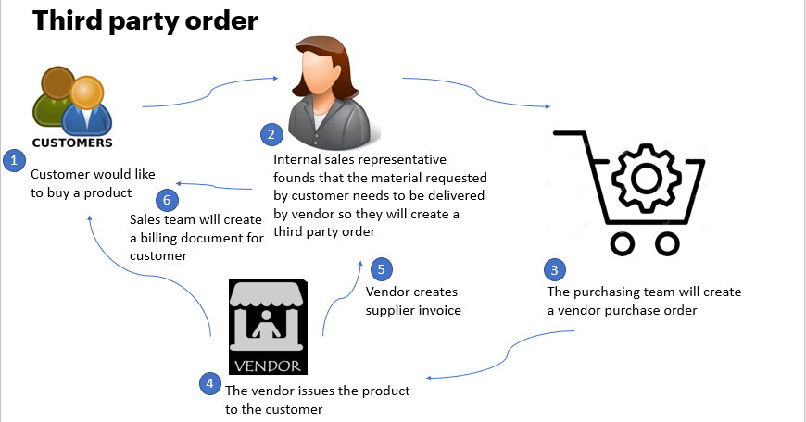

## High level requirements

Below are the high level requirements for this scenario

Some products will always needs to be delivered by vendor, so whenever business receives order for these materials, the order should automatically create a purchase requisition

Third party orders can be with shipping notification and without shipping notification. Whenever business wants to do the goods receipts, they will prefer to have third party order with shipping notification.

Master data requirements to differentiate the products that will be produced internally, which one will be procured and the materials for which the order must be outsourced

## Key Value Drivers for the Business Process

The order is delivered by the third party vendor on behalf of­ you

Most of the orders gets fully confirmed there by honouring the customer requirements

## Leading Practice Inputs

This scenario ties back to our golden template which talks about Living Business/Hyper-relevance. It means organization should contionously cater to its customers with right set of products and services.

Third party scenario ensures that goods are made available to the customers through networking and collaboration with vendors.

# Business Sub-Process Description

The sub-process describe how business leverage this solution to provide best service on time to the customer and maintain the relationship with customer and vendor simultaneuosly

## Business Sub-Process diagram

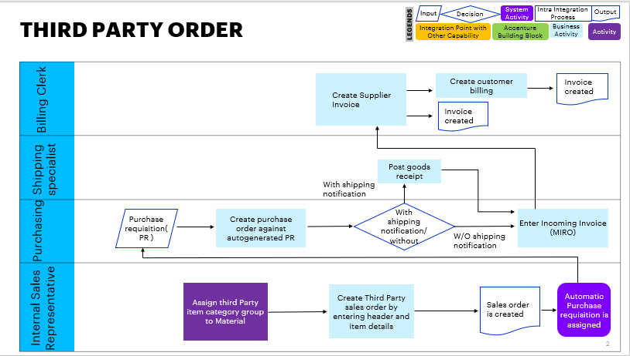

# Sub Process Activities

## Activity List

The following detailed activities takes place when we run end to end third party order

|  |  |  |  |  |
| --- | --- | --- | --- | --- |
| Name | Description | Transaction Code,  if relevant | Roles involved | Regulatory /Other Controls |
| Create customer | Customer with sales and FI details needs to be created | BP/Create customer | Master data specialist – customer data |  |
| Create material | Material with basic details and must be assigned the item category as BANS | MM01/Create material | Master data specialist – Product data |  |
| Create a third party order | Customer requests a product which will be delivered by vendor so create third party order | VA01/Create sales order | Internal sales representative |  |
| Create purchase order | The purchaser creates a purchase order for the vendor | ME21N/Create purchase order | Purchaser |  |
| Supplier invoice | Vendor creates an invoice once it delivers the product to the customer | MIRO/Manage supplier invoices | Accounts payable accountant |  |
| Create billing document | Company creates a billing document for the customer | VF01/Create billing document | Billing clerk |  |
|  |  |  |  |  |

## Inbound Communication

N/A

|  |  |  |  |  |
| --- | --- | --- | --- | --- |
| Activity | Type (email, form, handoff, etc) | Automatic/Manual | Source | Description |
| N/A | N/A | N/A | N/A | N/A |
|  |  |  |  |  |

## Outbound Communication

The Outbound Communication needs to be specifically documented for the client specific situation, like interfacing with external systems, workflow, form & Medium of communication.

|  |  |  |  |  |
| --- | --- | --- | --- | --- |
| Activity | Type (email, form, handoff, etc) | Automatic/Manual | Source | Description |
| N/A | N/A | N/A | N/A | N/A |
|  |  |  |  |  |

## Test Conditions

This section captures Test conditions for this sub process for the any specific client requirements. Generic test conditions for this sub process will be within the AAES test scripts.

|  |  |  |
| --- | --- | --- |
| Number | Test Condition – Action | Expected Result |
| 1 | Available under the test script document | TE586_OTC_Third Party Order_1909 |
|  |  |  |

# Sub-Process Variation

## Business Unit Led

N/A

## Geography/Legal Entity Led

N/A

# Role Definition & Organisational Impact

The content in this section will serve as input for the training and performance support team’s deliverables.

## Role/Skill Class Inventory

|  |  |  |
| --- | --- | --- |
| Role | Skills | Knowledge |
| Internal sales representative | SAP – OTC | Know how to create third party order, post goods issue and billing document |
| Purchaser | SAP – STP | Know how to create Purchase order and supplier invoice |

## Role Summary

|  |  |  |
| --- | --- | --- |
| Role | List of Steps | SAP Transaction |
| Internal sales representative | Create sales order  Post goods issue of the delivery  Create billing document | Create sales order( va01 )  Change outbound delivery( VL02N )  Create billing document( VF01 ) |
| Purchaser | Create Purchase order  Create supplier invoice | Create purchase order( ME21N )  Manage supplier invoice( MIRO ) |

## Organizational Impact

|  |  |  |  |  |
| --- | --- | --- | --- | --- |
| Reference # | Impact Description | Impact (H/M/L) | Impact Type | Impacted Groups |
| N/A | N/A | N/A | N/A | N/A |
|  |  |  |  |  |
|  |  |  |  |  |

# Process Fitness & Gap Analysis

## Process Fitness

|  |  |  |  |  |
| --- | --- | --- | --- | --- |
| Req ID | Short Description | Long Description | Req. Type | Accenture Reusable Assets |
| N/A | N/A | N/A | N/A | N/A |
|  |  |  |  |  |

## Gap Analysis

|  |  |  |  |  |  |  |
| --- | --- | --- | --- | --- | --- | --- |
| Country/ Region/ Business Impacted | Gap Description | Legal Req. (Y/N) | Magnitude of Impact (L/M/H) | Solution Type | RICEFW No. | Ref. to Req. id. |
| N/A | N/A | N/A | N/A | N/A | N/A | N/A |
|  |  |  |  |  |  |  |

# RICEFW

## Reports

|  |  |  |  |  |  |
| --- | --- | --- | --- | --- | --- |
| Client XYZ  RICEFW # | Report Description | Complexity (H/M/L) | Comments | Use from myConcerto/ARTL (New/Rework/Rep) | Ref # from RICEFW inventory |
| N/A | N/A | N/A | N/A | N/A | N/A |
|  |  |  |  |  |  |
|  |  |  |  |  |  |

## Interfaces (Inbound / Outbound)

|  |  |  |  |  |  |
| --- | --- | --- | --- | --- | --- |
| Client XYZ  RICEFW # | Interface Description | Complexity  (H/M/L) | Comments | Use from myConcerto/ARTL (New/Rework/Rep) | Ref # from RICEFW inventory |
| N/A | N/A | N/A | N/A | N/A | N/A |
|  |  |  |  |  |  |

## Conversions

|  |  |  |  |  |  |
| --- | --- | --- | --- | --- | --- |
| Client XYZ  RICEFW # | Conversion Description | Complexity  (H/M/L) | Comments | Use from myConcerto/ARTL (New/Rework/Rep) | Ref # from RICEFW inventory |
| N/A | N/A | N/A | N/A | N/A | N/A |
|  |  |  |  |  |  |

## Enhancements

|  |  |  |  |  |  |
| --- | --- | --- | --- | --- | --- |
| Client XYZ  RICEFW # | Enhancement Description | Complexity  (H/M/L) | Comments | Use from myConcerto/ARTL (New/Rework/Rep) | Ref # from RICEFW inventory |
| N/A | N/A | N/A | N/A | N/A | N/A |

## Forms

|  |  |  |  |  |  |
| --- | --- | --- | --- | --- | --- |
| Client XYZ RICEFW # | Form Description | Complexity (H/M/L) | Comments | Use from myConcerto/ARTL (New/Rework/Rep) | Ref # from RICEFW inventory |
| N/A | N/A | N/A | N/A | N/A | N/A |
|  |  |  |  |  |  |

## Workflows

|  |  |  |  |  |  |
| --- | --- | --- | --- | --- | --- |
| Client XYZ RICEFW # | Workflow Description | Complexity (H/M/L) | Comments | Use from myConcerto (New/Rework/Rep) | Ref # from RICEFW inventory |
| N/A | N/A | N/A | N/A | N/A | N/A |

# Integration Points

N/A

## Integration Issues

|  |  |  |  |  |
| --- | --- | --- | --- | --- |
| Issue # | Issue Description | Impact | Status | Resolution |
| N/A | N/A | N/A | N/A | N/A |
|  |  |  |  |  |

## Other issues

|  |  |  |  |  |
| --- | --- | --- | --- | --- |
| Issue # | Issue Description | Impact | Status | Resolution |
| N/A | N/A | N/A | N/A | N/A |
|  |  |  |  |  |

#### Revision History

|  |  |  |  |
| --- | --- | --- | --- |
| Date | Version | Description | Author |
| 12.12.2019 | V1.0 | Initial document | Kunal Prinja |
| 13.03.2020 | V1.1 | Updated with new template | Radhika Mandhana |